Alert Watch and Response Engine (AWARE)

**Version Description Document/Release Notes**

AWARE Version 1.1.11 Environment

for the

VA Long Beach Healthcare System in Long Beach



**Jan 2016**

Prepared by Harris Corporation

Revision History

| Creation Date | Version No. | Description/Comments | Author(s) | Reviewer(s) | Review Type | Issue Date |
| --- | --- | --- | --- | --- | --- | --- |
| 01/14/2016 | 0.01 | Release of AWARE Version 1.1.11 for VA Long Beach Healthcare System in Long Beach Test/Production environments. | G. Welch |  |  | 01/14/2016 |
|  |  |  |  |  |  |  |
|  |  |  |  |  |  |  |
|  |  |  |  |  |  |  |
|  |  |  |  |  |  |  |
|  |  |  |  |  |  |  |
|  |  |  |  |  |  |  |
|  |  |  |  |  |  |  |
|  |  |  |  |  |  |  |
|  |  |  |  |  |  |  |

Artifact Rationale

The Version Description Document (VDD) is the primary configuration control document used to track and control versions of software to be released to the operational environment. It is a summary of the features and contents for the software build. It identifies and describes the version of the software being delivered, including all changes to the software since the last VDD was issued. Every release of the software (including the initial release) shall be described by a VDD. Without this document, it would be nearly impossible to move an application or system from development to deployment reliably. Therefore the document is mandatory for each deployment.

Table of Contents

1 Scope 1

2 Version Description 1

3 Change Request Reports 2

4 Release Inventory 3

4.1 Electronic Media Released 3

4.2 Physical Media Released 3

5 Associated Supporting Documentation 3

6 Certification 4

7 Appendix A – Release Notes 5

7.1 Introduction 5

7.1.1 Purpose 5

7.1.2 Audience 5

7.2 This Release 5

7.2.1 Features and Functionality 5

7.3 Upgrades 5

7.4 Known Issues 6

7.5 Product Documentation 6

List of Tables

Table 1 - Change Requests for This Release 2

Table 2 – Inventory of Release Components 3

Table 3 – Associated Supporting Documentation 3

Table 4 – New AWARE Build Enhancement 5

# Scope

This Version Description Document (VDD) is the documentation provided by the Harris Configuration Management (CM) Manager to certify the integrity of the Alert Watch and Response Engine (AWARE) software deliverable that is being installed at the VA Long Beach Healthcare System in Long Beach for the Test/Production environments. This document pulls together all the approved Change Requests (CR) for all source code and electronic documentation deliverables for the AWARE Version 1.1.11. CM certifies that the delivery has been assembled under Harris standard process and has the integrity required based on the control, review, and audit procedures inherited in Harris CM processes.

The VDD is an inventory document for the AWARE Version 1.1.11, similar to a packing list for a received shipment, or a bill of lading. It itemizes the current test build baseline for recent deliverables in terms of implemented change requests. The build level version inventory for each installer is listed in Section 2. Appendix A contains the Release Notes that highlight the major functional or operational changes.

# Version Description

AWARE Version 1.1.11 consists of the product build from the AWARE Subversion (SVN) Version Control tool, all documentation, and applicable release notes produced to date by the AWARE team for VA. This includes final, customer accepted versions of documentation. All software configuration items are contained in the AWARE SVN Version Control tool Deployment folder in the VA VHA Innovation Sandbox, tagged as “AWARE Version 1.1.11”; all delivered software documentation is contained in the Harris SharePoint site. The executables were made with CM involvement, and therefore CM certifies the ability to reproduce it. All artifacts used to produce this delivery are in the CM Subversion repository and were managed by CM for producing the deliverable following CM processes and procedures.

The package named “AWARE Version 1.1.11” consists of the following files to describe this release:

* VDD and Release Notes: T4_AWARE_VersionDD-V1.1.11_LongBeach.docx
* *AWARE_v1.1.11_LongBeach.zip* containing the following files including installer file AwaredllInstaller-LON.exe for Long Beach below with date and time created, size, and SVN revision:

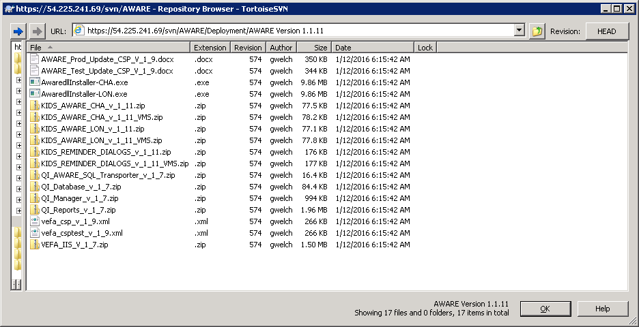

The KID_*.zip files for Long Beach have updates to the software (in the KIDS_AWARE_CHA_v_1_11.zip or KIDS_AWARE_CHA_v_1_11_VMS.zip for either a Linux or VMS VistA environment respectively). The Installer file AwaredllInstaller-LON.exe was also changed to reflect the new AWARE CPRS30A v69 executable for Long Beach. The Delphi 2006 source code for this version of CPRS including AWARE modifications has also been updated in the svn under trunk/CPRS. The executable was made to work with a sequence of VA patches for ICD10 incorporation outlined in the file “Install_list_for_AWARE_CPRS 30A_V69_toward_CPRS30B_V70.txt” which is also in the DEPLOYMENT folder in the svn.

AWARE Version 1.1.11 will be installed at the VA Long Beach Healthcare System in Long Beach. Files can be extracted from the local Long Beach server, VHALONAPP7 on C:\AWARE_INSTALLATION_SOFTWARE. These files (T4_AWARE_VersionDD-V1.1.11_LongBeach.docx and AWARE_v1.1.11_LongBeach.zip) are also in the svn.

# Change Request Reports

Harris only lists Change Requests relative to the latest baseline in this document. Harris will provide direct reference to Change Requests when necessary.

Table 1 - Change Requests for This Release

|  |  |
| --- | --- |
| **Change Request ID** | **Summary** |
| CR-76 | Correct CSP pages to handle apostrophes in field values. Code updated to prevent apostrophes in field values from causing invalid HTML Strings. |
| CR-78 | Add Team Security Key to AWARE Viewer and QI Tool. |
| CR-79 | “Update Current CPRSChart_Aware.exe to version 30A v69. The upgrade to ICD-10 caused the need for an emergency patch to CPRS 30A v16 before CPRS30B was ready. Latest patches had to be installed in a new CPRS30A/CPRS30B environment (the same patches for both up to v69 with last patch as OR*3.0*418). |
| CR-80 | Fixed Gap in updating certain Alert Cache entries with 14 day and 30 periods. 14 day updating boundary and final 30 day boundary on updating Alert Cache had small gap in updating data. Correct updating needs to be before last SQL update at most 30 days ( 14 days for those alerts with follow-up , and at most 30 days for those without follow-up) |
| CR-81 | Follow Action was not Tracked correctly with Orderable Item Status Changes.  For "Completion" status detection in orders (orderable items), change from "AC" to "AR" cross-reference. |
| CR-75 | “KB Editor Alert Type Name”  A code change made to account for multiple findings in ADDITIONAL FINDINGS field so as to find a first encountered HF to act as a validated entry even if other types of findings like Order Dialogs are entered in the Reminder Dialogs. |

# Release Inventory

The following table provides the released material inventory, describes the method of delivery, and to where and to whom the deliverable was released. The following table lists the release inventory.

Table – Inventory of Release Components

| **Release Component** | **Description** | **Method of Delivery** | **Recipient** | **Location** |
| --- | --- | --- | --- | --- |
| AWARE_v1.1.11_LongBeach.zip | AWARE Version 1.1.11 containing all files listed in Section 2 | Installation | VA Long Beach Healthcare System in Long Beach | VA Server VHALONAPP7 and VA VHA Innovation Sandbox and svn |
| T4_AWARE_VersionDD-V1.1.11_LongBeach.docx | Version Description Document and Release Notes for AWARE Version 1.1.11 | Email & upload | Blake Henderson, VA | AWARE SharePoint Site and svn |

## Electronic Media Released

The VDD and Release Notes and other product documentation are released via email. The software builds are delivered via upload to the VA VHA Innovation Sandbox. The Quality Improvement (QI) Reports are installed by Harris team members and the Kernel Installation and Distribution System (KIDS) build is installed by Office of Information and Technology (OIT) personnel at the VA Long Beach Healthcare System in Long Beach.

## Physical Media Released

Not applicable. There is no physical media provided with this deliverable.

# Associated Supporting Documentation

The following table lists the support documents that are associated with this deliverable:

Table – Associated Supporting Documentation

| **Document Name** | **Revision** | **Date** |
| --- | --- | --- |
| AWARE Implementation Plan and Checklist | 0.05 | 09/17/2014 |
| AWARE CPRS Integration Specification | 0.02 | 05/28/2014 |
| AWARE Requirements Specification Document | 0.03 | 05/09/2014 |
| AWARE User Interface Document | 0.02 | 05/29/2014 |
| AWARE Training Plan | 0.01 | 05/15/2014 |
| AWARE System Design Document | 0.01 | 05/27/2014 |
| AWARE Master Test Plan | 0.01 | 05/27/2014 |
| AWARE Requirements Traceability Matrix | 0.01 | 05/28/2014 |
| AWARE Test Cases | 0.03 | 04/15/2015 |
| AWARE Alert Cache Viewer User Guide | 0.03 | 07/20/2015 |
| AWARE Quality Improvement (QI) Report Manager User Guide | 0.02 | 09/04/2014 |
| AWARE Knowledge Base (KB) Editor User Guide | 0.02 | 09/04/2014 |
| AWARE Kernel Installation and Distribution System (KIDS) and Cache Server Page (CSP) Installation Guide | 0.05 | 07/20/2015 |
| AWARE Server Installation Guide | 0.05 | 07/20/2015 |
| AWARE_VistA_Configuration_Guide-Prod | 0.01 | 05/13/2015 |
| AWARE_VistA_Configuration Guide-Test | 0.03 | 01/06/2016 |

# Certification

The Harris Configuration Manager for this release certifies that the contents of the packaged release defined by this VDD consist of artifacts archived in the CM environment for AWARE Version 1.1.11as recorded in CM repository on 01/14/2016

The status of all change requests and code change requests listed in this document in the Change Record Reports section have been verified and are consistent with what is reported here.

________________________________________________­­­­­­­­­­­­____________________________

Signed Date

# Appendix A – Release Notes

## Introduction

The Computerized Patient Record System (CPRS) View Alerts package delivers notification of non-life threatening critical test results; however, it does not track whether providers take appropriate follow-up actions in response to the alerts. Currently, the only way to track follow-up actions on critical alerts is through manual review of individual patient records. The innovation Alerts, Watch and Response Engine (AWARE) will track and monitor follow-up actions thru AWARE modified CPRS and will identify certain critical lab and imaging test result alerts that lack timely follow-up in web based Alert Viewer application also accessible as a standalone application and thru a call-up from the Tools menu in either AWARE CPRS or regular CPRS. AWARE also consists of a web-based knowledge base editor and a quality measures reporting tool.

### Purpose

These release notes cover the new features provided to AWARE users in this release. All other documents referenced herein can be found at VA AWARE SharePoint site.

### Audience

This document targets users and administrators of the AWARE Test Build software product and applies primarily to the enhancements made to the AWARE prototype software.

## This Release

The following section provides, in brief, the new features and functions added to AWARE Version 1.1.11.

### Features and Functionality

Enhancements added as below for the AWARE 1.1.11 release.

Table 4 – New AWARE Build Enhancement

| **Features** |
| --- |
| VEFA AWARE TEAM ALERT CACHE key for Alert Cache Viewer for team members on same team to see their other team members’ alerts and any follow-up action on those alerts.  AWARE Reminder Dialogs enhancements made for Historical Event Future Health Factors).  TIU object code for future use. |

## Upgrades

Long Beach site OIT personnel will perform the upgrade to v1.1.11 in the Test or the Production environment by

* Installing the AWARE KIDS build for Long Beach (inside the KIDS_AWARE_LON_v_1_11.zip or KIDS_AWARE_LON_v_1_11_VMS.zip files). The instructions are in the document, AWARE_Test_Update_CSP_V_1_9.docx or AWARE_Prod_Update_CSP_V_1_9.docx.
* Upgrading the AWARE Computerized Patient Record System (CPRS) as version CPRS30A V69 can be done on desktop workstations using the AwaredllInstall-LON.exe executable.
* The AWARE Reminder Dialogs have been upgraded to use Historical Events (Forward Health Health Factors) for improved follow-up tracking. The instructions are found in the

AWARE_VistA_Configuration_Guide-Test.docx or AWARE_VistA_Configuration_Guide-Prod.docx documents. For a subsequent install beyond a previously first time install into a Production environment, a refactoring of orderable items and order dialogs should be made using the instructions in the AWARE_VistA_Configuration_Guide-Prod.docx document. A subsequent install into an AWARE Test environment does not necessarily need a refactoring initially until such time a refactoring is used as explained in the AWARE_VistA_Configuration_ Guide-Test.docx.

All related AWARE Version 1.1.11 components can also be found on the VHALONAPP7 server in the C:\AWARE_INSTALLATION_SOFTWARE folder and in the svn.

## Known Issues

There are no known issues specific to this release as this time.

## Product Documentation

The documents listed in Section 5, Table 3 apply to this release.

These documents were delivered to VA by email and reside in VA’s AWARE SharePoint site: <http://vaww.oed.portal.va.gov/projects/aware/default.aspx>